Heading 1: Accessible Word template [only 1 Heading 1 per page]

This is a Heading 2, or a sub heading
This is a “body text” Using clear, logical headings can go a long way in making your Word documents meet global accessibility standards.
This doc was made with the “Outline” mode, found under “View”
Many people use headings to scan documents and jump to content they want. Make sure you keep your headings in logical order (heading 1, heading2, heading 3… not heading 3, heading 2, heading 1). This can also help you avoid table at times when they are not necessary. Banner paragraph text can help emphasize topics, too.

Try Banner paragraph text
You can create a paragraph or words with banners. This shades the text to help emphasize it. Shading words or paragraphs gives them a background color that updates when you switch to a different document theme. It's different from highlighting text, which has a very limited choice of colors, and doesn't update when you switch to another theme. Combining headings and banner text is recommended in place of tables, wherever possible.
- Select the word or paragraph that you want to apply shading to.
- On the Home tab, in the Paragraph group, click the arrow next to Shading.
- Under Theme Colors, click the color that you want to use to shade your selection.
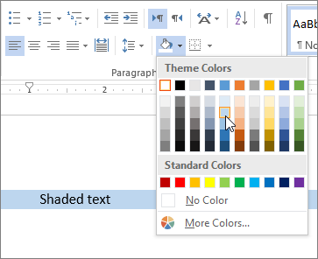

Another level 2

Level 3 (like this) may be used to help convey more info, but keep it short
Insert detailed information here. “Body text” is for the detailed information. Try to keep this part no longer than a few paragraphs
This doc was made with the “Outline” function, found under “View”
See the image of this document in outline mode below. Once “outline” is selected, “Outlining” appears to the right-hand side of “File” :
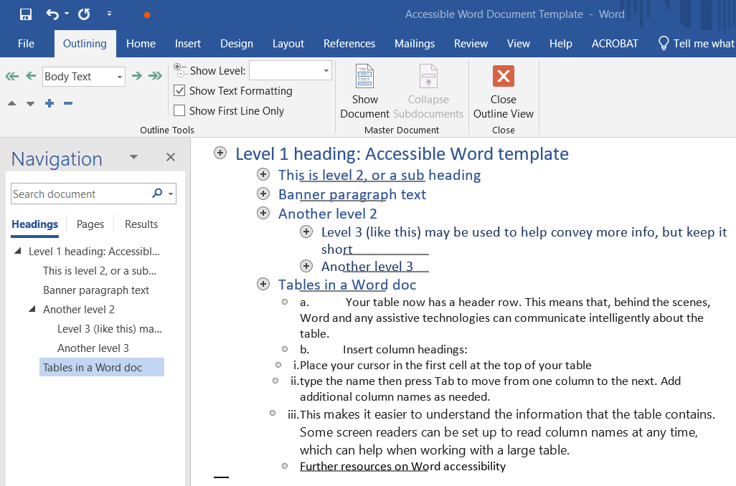

Make sure your headings are short, specific to the info that follows them, and clear to users new to the topic.
At this point, if you want another heading, click on “Outlining” and then in the first drop down menu, select the heading size (level 2, level 3, level 4… remember to keep it logical)

Another level 3
Here is a screenshot to help find the menus items described above. If you use images, always include alternative text (alt-text) to help your learners using screen readers or other assistive technology and for when the image fails to load. Right click on the image, then select “edit alt text.” Then describe what is in the image and give its context if it’s not already in text near it. Do not select “mark decorative” on images helping you convey an idea or information.
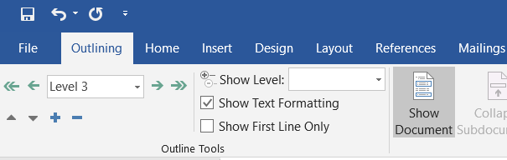

Tables in a Word doc
In general, avoid tables if possible and present the data another way, like paragraphs with headings and banners. If you find that a table is necessary for your Word doc, follow these steps.
- Choose Insert > Table to insert a table.
- Choose the number of boxes you want across to create columns, and then choose the number of boxes you want down to create rows for your table.
- On the Design tab, choose the Table Styles Options group, and then choose Header row. Other options include Banded Rows or Total Row.
  - Your table now has a header row. This means that, behind the scenes, Word and any assistive technologies can communicate intelligently about the table.
  - Insert column headings:
    - Place your cursor in the first cell at the top of your table
    - type the name then press Tab to move from one column to the next. Add additional column names as needed.
    - This makes it easier to understand the information that the table contains. Some screen readers can be set up to read column names at any time, which can help when working with a large table.

Further resources on Word accessibility
Microsoft 365 Support: “Make your Word documents accessible to people with disabilities”
Microsoft 365 Support – video “Create Accessible Tables” (with a detailed how-to guide)

